**Defining family violence**

Family violence is any **threatening, violence, dominating or abusive behaviour** that occurs not once but continuously between people in a family t**hat causes the person experiencing the behaviour to feel fear**.

Family violence is not just physical or sexual abuse. It can include many types of abuse all of which are unhealthy and harmful.

### Types of family violence relationships

* **Intimate partner abuse:** violent behaviour used by a current or former spouse or partner against the other spouse or partner.
* **Dating abuse:** violent behaviour used by a casual partner against the other partner.
* **Child abuse:** violent behaviour or mistreatment towards a child or young person by a parent or caregiver.
* **Elder abuse:** violent behaviour or mistreatment towards an older person by a partner or family member, often including financial abuse, controlling behaviours and/or negligence.
* **Parental abuse:** violent behaviour towards a parent by an adolescent child or dependant.

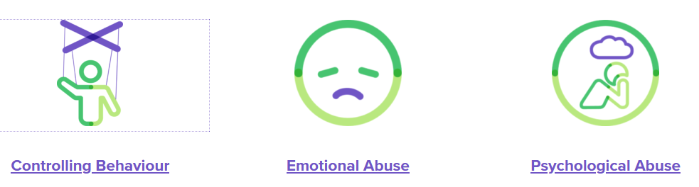

**Some examples of controlling behaviour are when someone…**

* Insists on knowing where you are and who you are with all the time, or won’t let you go out without them. If you do, they become angry or sullen
* Won’t let you see certain people, like extended family or friends, or discourages you from seeing them. This is called ‘isolating’
* Calls you excessively to see where you are or makes you prove where you are
* Goes through your text messages or social media to see who you’ve been talking to and what you’ve said
* Tells you what you can or can’t wear
* Stalks you or tracks you using any kind of technology

**Some examples of emotional abuse are when someone…**

* Puts you down all the time or criticises you, calls you names, makes you feel like you’re not good enough or can’t do anything right
* Blames you for problems in the relationship
* Yells or swears at you
* Ignores you
* Makes you feel guilty if you don’t do what they want
* Embarrasses you in front of other people
* Threatens to harm or kill themselves so you do what they want

**Some examples of psychological abuse are when someone…**

* Makes you doubt your own recollections or tells you things didn’t happen when they did (this is sometimes called gaslighting)
* Tells you that you are crazy or have mental health concerns
* Tells you you are imagining or over-exaggerating their abusive behaviour
* Tells you or other people – including friends, police, doctors, counsellors or legal professionals – that *you* are the one being abusive towards them when you are not or you are just defending yourself in response to their abuse or manipulating behaviour (this is sometimes called victim-playing)
* Telling other people – including friends, police, doctors, counsellors or legal professionals – that you are unstable, have mental health problems or substance abuse problems when you don’t



**Some examples of financial abuse are when someone…**

* Controls access to finances, won’t let you access bank accounts or credit cards
* Expects you to pay for bills, groceries and other basic necessities but gives you little or no money to cover those costs
* Forbids you from working or deliberately sabotages your ability to get or hold down a job
* Refuses to work or contribute to family expenses
* Takes your pay or your Centrelink benefits
* Takes out loans or accrues debt in your name
* Files false insurance claims or Centrelink benefits under your name
* Doesn’t include you in significant investment or banking decisions
* Refuses to pay or evades child support

**Examples of sexual abuse**

* Rape – any sexual activity with someone who has not given consent
* Sexual contact when the other person is unable to consent, perhaps because they are drunk or unconscious
* Not using protection when the other person wants to do so
* Deliberately causing unwanted pain during sex, unwanted rough or violent sexual activity
* Unwanted exposure to pornography
* Sharing sexual photos, videos or messages of someone without their consent

**Examples of physical abuse**

* Pushing, shoving, slapping, scratching, biting, kicking or hair pulling
* Maiming someone
* Restraining (eg. pinning someone against a wall or bed)
* Choking, strangling or shaking
* Throwing objects
* Threatening with a weapon
* Hurting children or pets
* Sleep and food deprivation
* Driving recklessly